System Properties
A Java program can access System Properties to find information about the environment.
In BlueJ you can do this interactively. Otherwise, create a Java class with a main method:
> import java.util.Properties;
> System.getProperty("user.name")
hacker
> System.getProperty("java.version")
"1.7.0_15"
> Properties props = System.getProperties( ); // get all properties
> props.list( System.out ); // print them
There are 3 ways to set system properties:
1. Define them on command line (scope is that shell) or in "My Computer" dialog box.
cmd> SET user.name=Superman
2. Define System properties at run-time using the -D flag. For example:
java -Duser.name=Superman purse.Main
3. In Eclipse, you set system properties by changing the run configuration.
Choose Run -> Run Configuration... Choose a configuration and select the Environment tab:
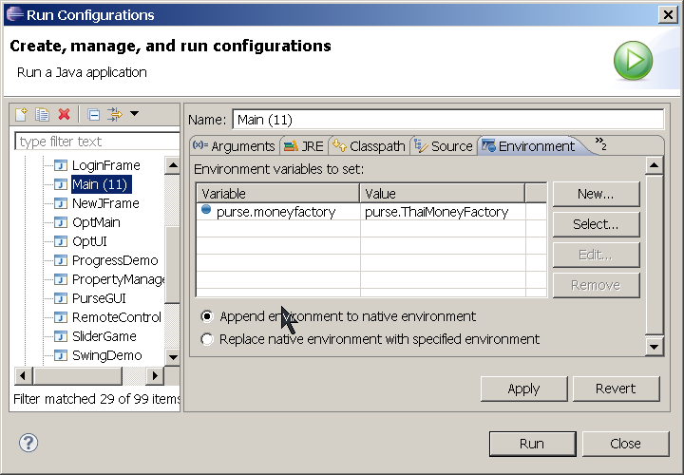
However, using System properties for application properties is unreliable and difficult for the user to manage. Java has two much better mechanisms: java.util.Properties and ResourceBundle.

Problem 2: Create Properties for the Purse
You can define properties for your application by putting them in a plain text or XML file. Many applications use plain text because it's easier for humans to edit. Here is an example:
File: purse.properties
# Purse properties
# Lines beginning with # are comments
currency=Baht
# full name of Java class containing a WithdrawStrategy
strategy.class = coinpurse.strategy.RecursiveWithdraw

Lines that begin with # are comments. Comments and blank lines are ignored. This file contains 2 properties in the form key=value. Spaces around the key name and = sign are ignored.
Notice that a property name may contain periods, such as "strategy.class". This avoids name conflicts (called naming collision) in property names used by different components.

2.1 How to Access Properties
The java.util.Properties class is a map of key-value pairs, where keys and values are String. The Properties class also has methods to read properties from disk or write them to disk.
String getProperty(String key)  String getProperty(String key, String default) | Get value of a property.  If property key is not found then return default.
load(InputStream instream) | Read properties from InputStream
loadFromXML(InputStream instream) | Read properties from instream in XML format
boolean containsKey(String key) | return true if properties map contains key
Set<String> stringPropertyNames() | Get set of all property names. keySet() and propertyNames() also return this, as Objects.
other methods inherited from Hashtable

2.2 How to Read Properties from a File
Use properties.load(InputStream) to read the data from any InputStream.
InputStream input = new FileInputStream( "purse.properties" );
Properties properties = new Properties( );
properties.load( input );
input.close( );
Unfortunately, this code usually doesn't work.
Opening files in Java is a problem because the "current directory" is the current directory of the JVM, which may not be the directory of the application. Or, the properties file may be bundled inside a JAR file!
A solution is to open the file as a Resource, as you did in the Cheap Digital Clock assignment.
The ClassLoader has a method named loadResourceAsStream(String name) that searches for resources anywhere on the CLASSPATH, which includes files inside a JAR. It returns an InputStream. The Class class also has a loadResourceAsStream() that does the same thing.
String filename = "purse.properties";
// get the classloader for a class in your application
ClassLoader loader = PropertyManager.class.getClassLoader( );
InputStream instream = loader.getResourceAsStream( filename );

2.3 Create a PropertyManager for Purse Properties
Providing access to properties is a new responsibility. Many parts of our application may want to use properties, so we should create a separate class to manage properties. Name this class PropertyManager.
An application has only one set of properties; so PropertyManager can either be a Singleton or use static methods. The example code uses static methods.
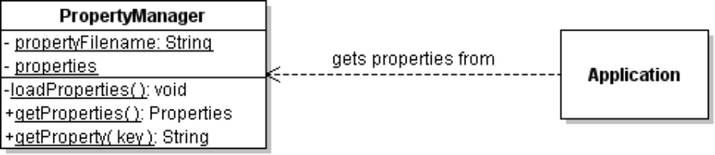
PropertyManager has a getProperties() method to get the Properties object. For convenience, also provide a getProperty(key) method to get the value of one property.
1. Download PropertyManager.java from the class repository.
2. Add it to your project in the coinpurse.util package.
3. Write the getProperty(String key) and getProperties() methods.
package coinpurse.util;
public class PropertyManager {
private static String PROPERTIES_FILENAME = "purse.properties";
private static Properties properties;

static {
loadProperties( PROPERTIES_FILENAME );
}
/** Load properties from a file or resource by name.
* @param filename file or resource name
*/
private static void loadProperties(String filename) {
properties = new Properties();
InputStream instream = null;
try {
instream = new FileInputStream( filename );
} catch ( Exception e ) { /* try again */ }

if (instream == null) {
ClassLoader loader = PropertyManager.class.getClassLoader();
instream = loader.getResourceAsStream( filename );
}
if (instream == null) return; //TODO log the failure
// get the property data
try {
properties.load(instream);
} catch (IOException e) {
System.out.println("Error reading properties file "+filename);
}
// close input stream to free resources
try {
instream.close();
} catch (IOException ioe) { /* should not happen */ }
}
//TODO: getProperty(String key)
//TODO: getProperties()
The static block is executed when the class is loaded. If you prefer, you can make PropertyManager a Singleton with instance methods for getProperty() and getProperties().

2.4 Test the PropertyManager
Try getting the properties and printing them on the console. In BlueJ:
> coinpurse.util.PropertyManager.getProperty("currency")
Baht
> Properties props = PropertyManager.getProperties( );
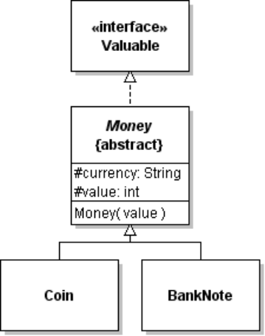
> props.list( System.out );

Problem 3: Set Currency using a Property
3.1 Coin and BankNote get the currency from the Money class. Modify the Money class to set the currency using the "currency" property.
3.2 Test it. Create a Coin or BankNote and invoke toString().
It should print the currency as in the purse.properties file.
> PropertyManager.getProperty("currency")
Dong
> Coin coin = new Coin( 5 );
> coin.toString()
5-Dong coin

Problem 4: Create a MoneyFactory
In a previous lab, we used a ConsoleDialog to deposit Coin, BankNote, and Coupon objects into the Purse. The user enters the values on the console:
Please enter d (deposit), w (withdraw), p (print), or q (quit): d
Enter the values deposit [eg: 5 5 1 blue]: 5 red 50
Deposit 5-Baht... ok
Deposit red coupon... ok
Deposit 50-Baht BankNote... ok
Purse contains 155 Baht
The ConsoleDialog creates objects by parsing the input (Strings) and creating new Coin, BankNote, and Coupon objects.
This means that the user interface has to know which values should be Coin, which values should be BankNote, and which should be Coupon (and the Coupon colors). This makes the code difficult to maintain.
4.1 Create a MoneyFactory class with a single method that creates a Valuable object using a String parameter.
For example:
Valuable x = moneyFactory.createValuable("1"); // returns a Coin
Valuable y = moneyFactory.createValuable("100"); // returns a BankNote

MoneyFactory
+createValuable(String name): Valuable
The rules for createValuable( ) are:
- if the name parameter is null throw IllegalArgumentException
- if the parameter is "1", "2", "5", or "10" create and return a Coin
- if the parameter is "20", "50", "100", "500", or "1000" create and return a BankNote
- for any other name, if there is a property named "coupon.name" that matches the parameter, with an int property value, then create a coupon with this value. For example:
# purse.properties
coupon.red = 100
coupon.blue = 50
coupon.pink = 500
then createValuable("pink") should return a pink coupon with value 500.
- for any other parameter value throw IllegalArgumentException
- Don't write
if (name.equals("1") || name.equals("2") || name.equals("5") ...
use a HashSet or HashMap of valid String values for Coin and BankNote. Or, use a property.
- Try to write easy-to-maintain code so we can change the values of coins and banknotes.
4.2 Make MoneyFactory be a Singleton class with a static getInstance() method.
The 3 components of a Singleton are:
a) private constructor
b) a private static instance of the class
private static MoneyFactory singleton; // any variable name
c) public static accessor method, usually named getInstance().
Use lazy instantiation of the singleton factory object. This means that you don't create the singleton object until it is needed.
static MoneyFactory getInstance( ) {
if ( singleton == null ) {
// haven't created singleton yet. Create it now.
singleton = new MoneyFactory( );
}
return singleton;
}
4.3 Modify the ConsoleDialog to create Valuable objects using MoneyFactory.
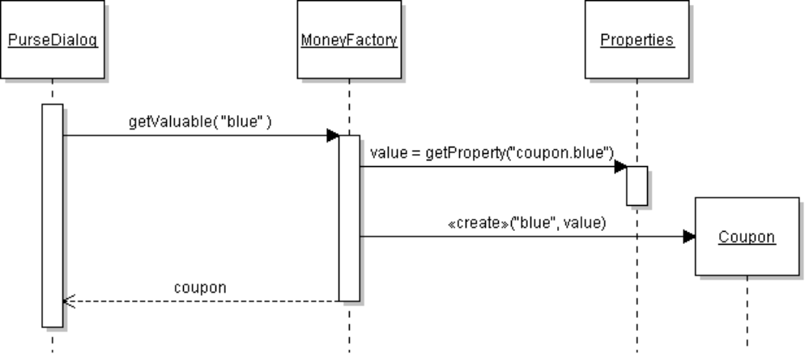

Problem 5 (Optional). Create a Strategy Factory for WithdrawStrategy
In Lab 11, you added WithdrawStrategy to the Purse. How can we change the WithdrawStrategy that the Purse uses?
Use a StrategyFactory to create the WithdrawStrategy object, and use a Property to specify which strategy to create.
For example, in the Purse class:
// get the withdraw strategy
WithdrawStrategy strategy = factory.getWithdrawStrategy( );
5.1 Create a StrategyFactory class with a getWithdrawStrategy() method that returns a WithdrawStrategy.
getWithdrawStrategy should always return something, so you should use a default strategy:
set classname = value of Property "strategy.class"
if classname is not null then
set withdraw strategy = object created from classname
endif
if withdraw strategy is null
set withdraw strategy = a default withdraw strategy (use Greedy as default)
To create an object from a String (classname) you can use this code:
try {
strategy =
(WithdrawStrategy) Class.forName(classname).newInstance();
} catch (Exception e) {
// log the exception
}
Class.forName("classname") returns the Class object for a named class. For example, to create a new Date object you can use:
Date d = (Date) class.forName("java.util.Date"),newInstance();
5.2 Make StrategyFactory be a Singleton class
We only need one StrategyFactory. The code for this is same as in Problem 4 (MoneyFactory).
5.3 Modify the Purse to get WithdrawStrategy from the StrategyFactory.
5.4 Test It: Change the strategy in purse.properties
A good test would be to define a Strategy that didn't exist before:
public class DumbWithdrawStrategy implements WithdrawStrategy {
public List<Valuable> withdraw(int amount, List<Valuable> list) {
if (! list.isEmpty() ) return list.get(0);
return false;
}
}
#purse.properties
stategy.class = coinpurse.strategy.DumbWithdrawStrategy
Problem 5: Apply Singleton Pattern to StrategyFactory
, so define StrategyFactory as a Singleton. The Singleton makes it easy for our application to access the StrategyFactory.
2.1 Write a static getInstance() method to get an instance of the factory. For example:
StrategyFactory factory = StrategyFactory.getInstance( );
WithdrawStrategy strategy = factory.getWithdrawStrategy();

2.3 Test that the factory object returned is really a singleton. This means, every time we call it, it returns the same object reference.
StrategyFactory sf1 = StrategyFactory.getInstance( );
StrategyFactory sf2 = StrategyFactory.getInstance( );
if ( sf1 == sf2 ) System.out.println("factory is singleton");
else System.out.println("different objects. not a singleton");

